Jose Berlingeri, jberlingeri3, Section A

Victor Rohlfs, vrohlfs3, Section A

Rohith Ravi, rravi6, Section A

Brian Cai, GT bcai7, Section A

[37]

[Phase 2]

EER Diagram:

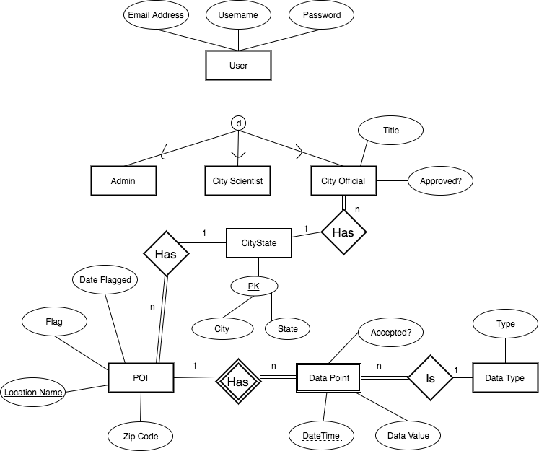

Relational Schema Diagram:

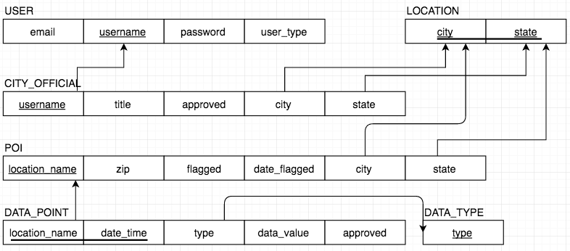

SQL Statements:

SQL Assumptions:

* City Official attribute **Approved** is a Boolean attribute set to Default as FALSE (i.e. “pending”). The value TRUE would mean the City Official is “approved”. If the City Official is ever denied registration or fired, then we assume that it will be deleted from the database.
* In the application, any **State** attribute will follow the abbreviated state name format “XX” (i.e. “GA”, “FL”). For that reason we defined the domain constraint as Char(2).